**CASTILE UNITED CHURCH OF CHRIST**

**4 Washington Street Castile, NY 14427**

Sun., August 27, 2023 10:00 AM

🙜 🙜 🙜 🙜 🙜 🙜 🙜 ( - Please stand if able) 🙜 🙜 🙜 🙜 🙜 🙜 🙜

Prelude

Ringing of Tower Bell

Announcements

❖**Opening Hymn No. 43 “Great is Thy Faithfulness”**

**Call to Worship** (Please be seated)

Pastor: Family of God, as we gather today, Jesus asks us,

“Who do you say that I am?”

**People: You are our Messiah, the Son of the living God!**

Pastor: Family of God, as we gather today, the Holy Spirit asks us,

“Who do you say that I am?”

**People: You are our Comforter, Advocate, and Sustainer!**

Pastor: Family of God, as we gather today, God the Father asks us,

“Who do you say that I am?”

**People: You are our Creator, Provider, and Healer**

Pastor: Family of God, as we gather today, the Triune God asks us,

“Who do you say that I am?”

**People: You are love that creates, saves, and enfolds us into the**

**family of God! May we be instruments of love. Amen.**

**❖Prayer of Invocation:**

**We look for you in all the wrong places, God of the lost, and wonder why we cannot find you. We wander the corridors of power, while you are on the sidewalks, beside the homeless.  
We sit at the head tables of the world, while you are handing out**

**soup to the hungry at the kitchen's backdoor. We applaud those who win the race, while you are cheering on those in last place. In granting us mercy, you challenge us to think of all those we have ignored. In gifting us with grace, you enable us to proclaim Jesus Christ, our Lord and Savior, as the hope, the joy, the peace the world seeks. Amen**

❖**Gloria Patri**

Old Testament Reading: Exodus 1:8-10

Childrens Message: “Baby Moses by the River”

Gospel Reading: Matthew 16:5-12

❖**Hymn of Reflection No. 460 “All The Way My Savior Leads Me”**

**Vs. 1 & 2**

Message: ”How Would You Answer This Question?

*You Tube: “Voice of Truth” by Casting Crowns*

Sharing Joys and Concerns

Silent Prayer Pastoral Prayer

**The Lord’s Prayer (sins)**

❖**Closing Hymn No. 47 “God Will Take Care of You” Vs. 1 & 3**

Benediction

Postlude

🙜 🙜 🙜 🙜 🙜 🙜 🙜 🙜 🙜 🙜 🙜 🙜 🙜 🙜 🙜 🙜 🙜 🙜 🙜 🙜 🙜 🙜

**Our Offering Plates are located in the church narthex.**

*If you are a guest here today, we welcome you and invite you to*

*visit us again whenever possible. Please introduce yourself to our Pastor, Tammy Lathan, before you leave today.*



**Announcements August 27, 2023**

**\*\*\*\*\*\*\*\*\*\*\*\*\*\*\*\*\*\*\*\*\*\*\*\*\*\*\*\*\*\***

🕮 **Today: Sunday, August 27**

**10:00 AM - Worship**

**11:00 AM - “*Coffee & Conversation”***

**7:30 PM -** A.A. Meeting

**September**

**Fri. 1 – 10:00 AM –** WF to price baked foods at church

**Sat. 2 9:00 AM-** Baked Food Sale at Woodstream Campground

******

🕮 **Sunday, September 3**

**10:00 AM - Worship Service**

**11:00 AM - *“Coffee & Conversation”***

**7:30 PM -** A.A.

**Mon. 4 – Labor Day**

**Thur. 7 6:00 PM-** Castile Historical Society

**6:30 PM- Bd. of Elders meeting**

**\*\*\*\*\*\***

🕮 *For appointments contact*

*Pastor Tammy at 585-969-0695*

**\*\*\*\*\*\***

**Volunteers Needed:**

For a Sunday Morning Facebook Team. If you would be able to help out with recording our Sunday Morning worship, please contact Pastor Tammy. The goal is to put together a monthly schedule of volunteers. Step by Step instructions make the job easy. Please consider helping with this amazing Ministry. Thank you!

Pastor: Tammy Lathan

Cell Phone: 585-969-0695

Church Office: 585-493-2840

**Church Office & Building Hours:**

**Tuesday - Friday**

**8:00 AM - 2:00 PM**

**Or by appointment**

E-mail: [Castile_UCC@yahoo.com](mailto:Castile_UCC@yahoo.com)

Website: [www.castileucc.com](http://www.castileucc.com)

Director of Music &

Church Choir Director

**Barbara Meyer**

Handbell Choir Director

**J. Thomas Reagan**

Worship Technology Team

**Charles Miller Tom Reagan**

**Barb Meyer Steve Meyer**

**Jeff Mattingly James Loomis**

**Tyler King Ron Lathan**

Altar Flowers:

**The Scott Family**

(In memory of Carol Casselberry)

Music Today:

**Lisa Gunn**

Lay Leader:

**Jacob Klein**

**Attendance 8/20/23**

51 in person 92 FB views

**Deposits for 8/20/23**

**Operational: $592.00**

**Loose: $60.00**

**Pop cans: $87.80**

**Total: $739.80**

**Missions: Gen Fund $8.00**

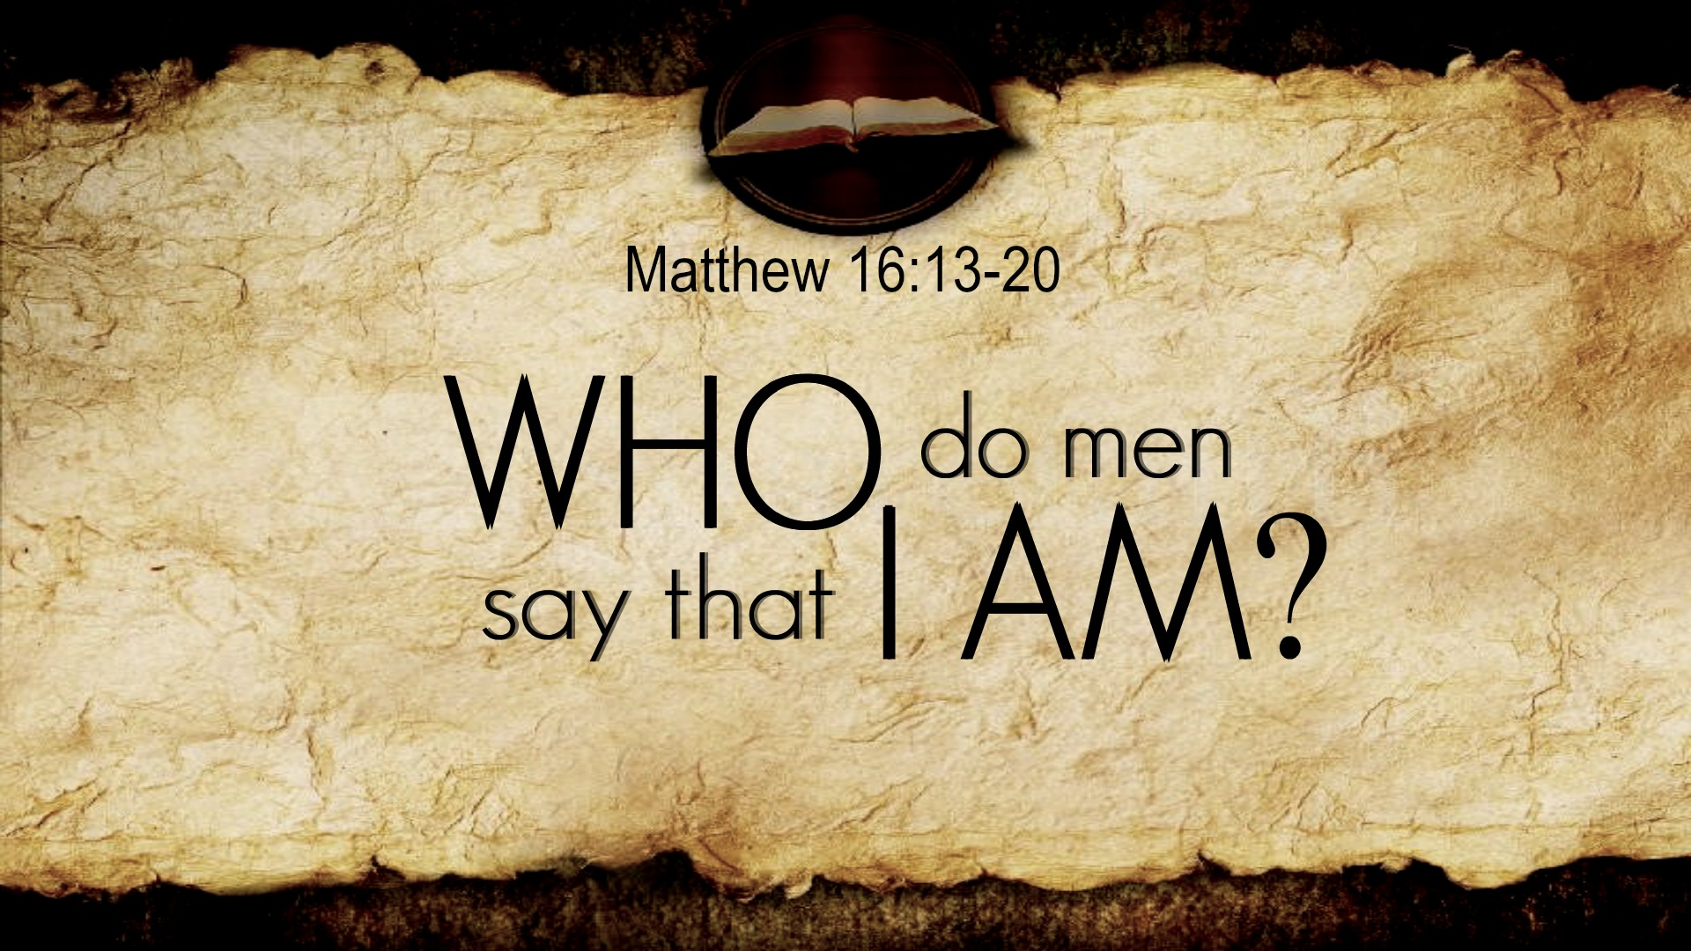

**Sunday, August 30, 2023**

**Castile United Church of Christ**

**4 Washington Street**

**Castile, NY 14427**